Accessing PeopleSoft

As a Self-Service employee you will be provided with access to the PeopleSoft HRMS system. This access will allow you to enter your requests for leave, add or modify personal information such as address, phone number and emergency contact information. You will also have the ability to view your pay advice, leave and compensatory bank balances and print your T4.

You can access the PeopleSoft application using the following URL or through the Insite portal as outlined below.

https://psprdapp.gov.pe.ca:8001/psp/PSPROD92/?cmd=login

Insite Portal:

Steps:

- Log into the Insite portal using the User ID and password provided to you from IT Shared Services.
- A menu will be displayed at the top of the page.
- Click on the button and a list of options will be displayed.

- Click on Leave from the list provided and the Leave page will be opened.

- Under the Request Leave section of the page click on the Go to Leave Application button.

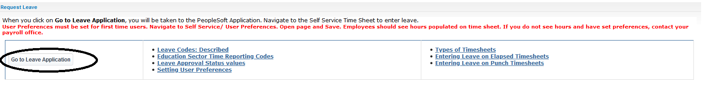
- The PeopleSoft Sign In page will be opened.

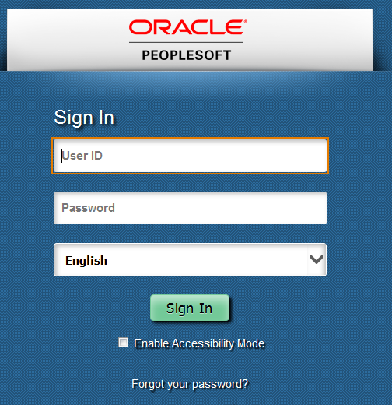

Enter your PeopleSoft User ID and password. The User ID will be in upper case letters. When entering your User ID the application will automatically format the User ID to upper case.
The password field is case sensitive. The password must be entered in the same format it was created. The password must be a minimum of eight characters, must include at least one uppercase letter, must include one number and must include one special character.



When you have completed entering your User ID and password, click on the  button.

The application will be opened to your Home page. The Home page will include Tiles that allow you to navigate to various pages within the PeopleSoft application.

The blue header bar on the page will display a role. As a PeopleSoft Self-Service user you have been assigned the role of Employee Self Service.

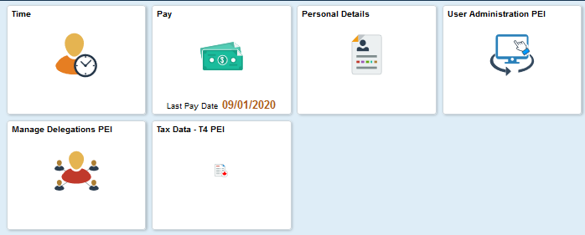

USER PREFERENCES PROCESS:

If this is your first time entering leave in PeopleSoft, you will need to complete a one-time only User Preferences process. Upon completion of this step, your work schedule will automatically populate your timesheet.

- Click on the User Administration PEI tile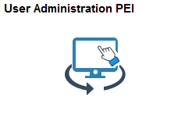

The following screen will be displayed. Choose User Preferences on left-side of screen.
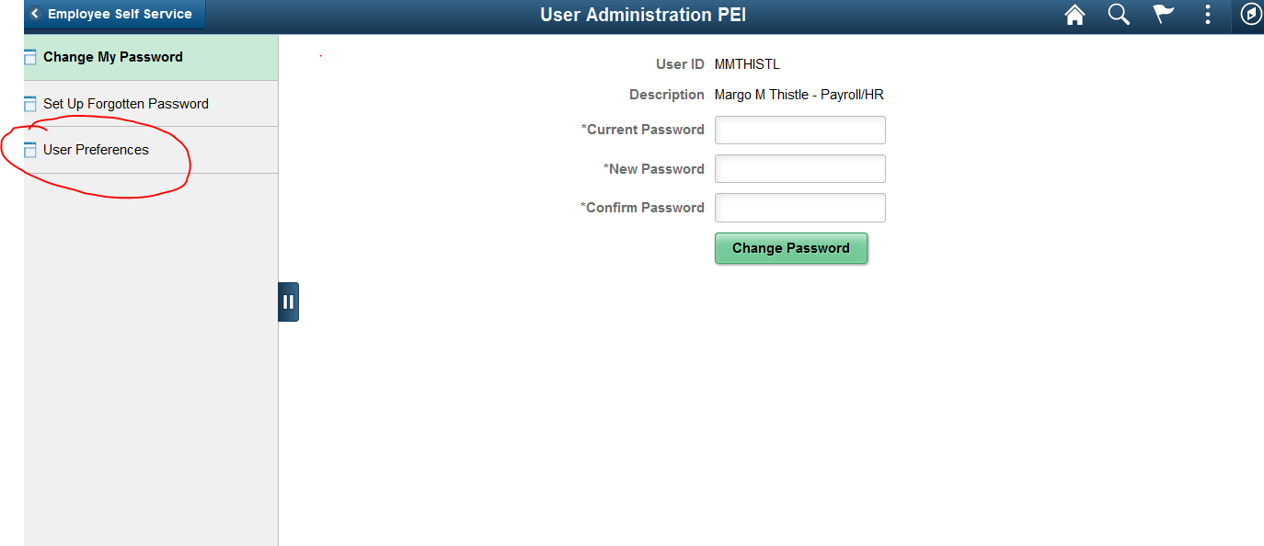

- Accept the default settings by clicking on .

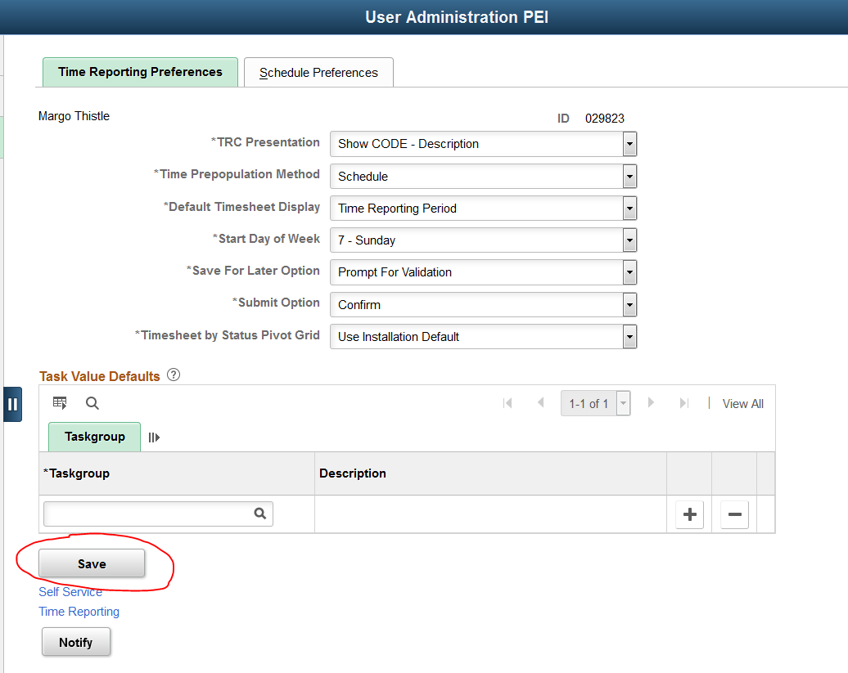

- Navigate back to the Employee Self Service tiles by clicking on or the  button as shown below.

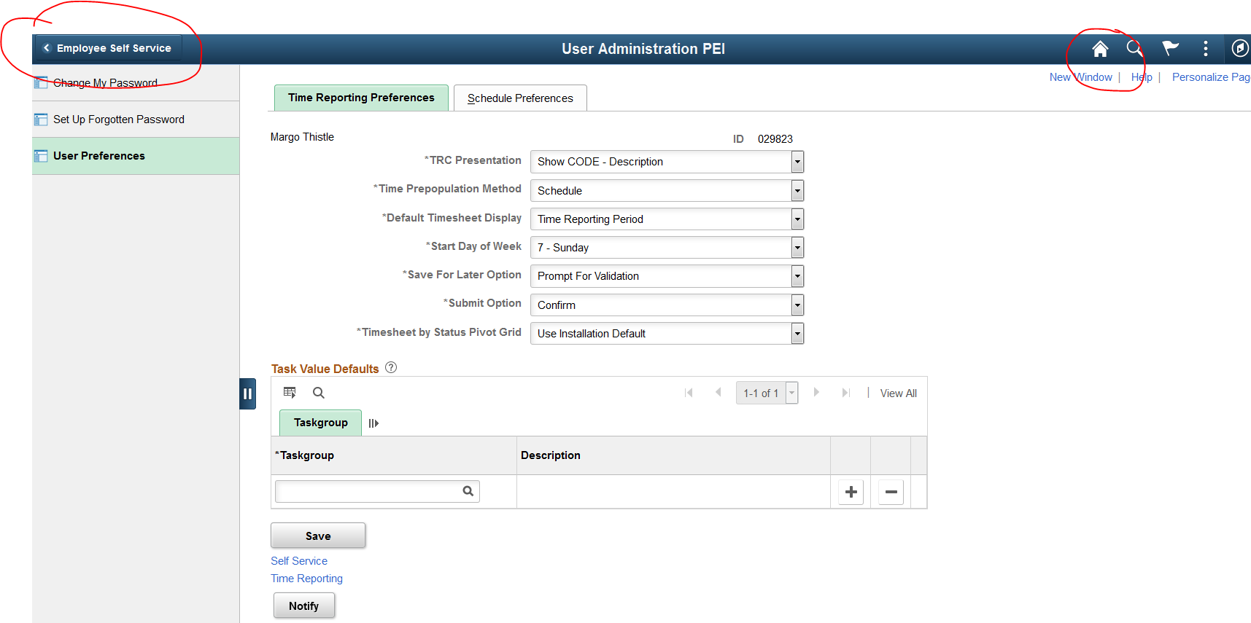

Entering Requests for Leave

The following leave types can be reported using PeopleSoft Self Service:

Vacation Election Leave
Sick Illness in Family
Blood Donor Medical Appointment
Birth/Adoption (Partner) Personal Leave Unpaid
Compassionate Leave Overtime Taken in Lieu
Court Union Business
Education – Attending Workshops Long Standing Service Leave

The following outlines the steps for reporting leave on your timesheet.

Steps:

- Click on the Time Tile.

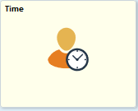

If you hold more than one job, ensure the job reflected in the Select a Job field is correct for the record you want to update or click on the down arrow and selected a different job.

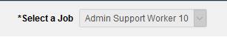

- Click on the Enter Time Tile.

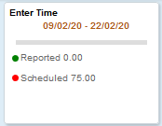
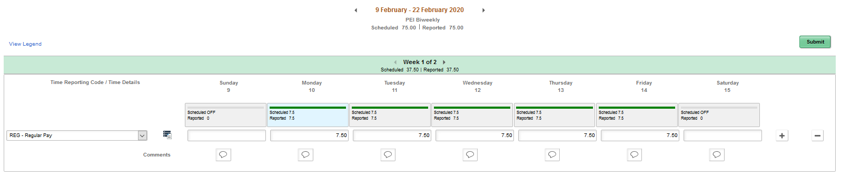

When viewing your timesheet in a pay period that has a statutory holiday, your timesheet should continue to display as “Regular Pay” if the statutory holiday falls on a day that would have been a normal workday for you. The system or your HR/Payroll office will automatically make any required adjustments. Automatic adjustments will also be made to those holidays that fall on a weekend where you would be receiving the next regularly scheduled work day off in lieu of the statutory holiday.

- The timesheet will be opened to the first week in the pay period based on the current date. To navigate to a previous or future pay period click on the arrows displayed before and after the date range displayed at the top of the page.


- The time reported on your timesheet will be displayed one week at a time. The green bar will display the week in the pay period based on the current date (i.e. Week 1 of 2 or Week 2 of 2). If you want to navigate to a different week in the pay period, click on arrows displayed before and after the Week field.

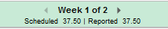

- Your normal scheduled work hours will be displayed for each day in the pay period being viewed.
If, at any time, your timesheet does not reflect your actual normal work schedule contact your HR/Payroll office. They will assign the correct schedule to your record. Do not make changes to your schedule unless you are entering a leave request that replaces an existing scheduled day.

- When you are requesting leave for a full shift, highlight and delete the hours that are reported under the Regular Pay row for the appropriate date. If you are only requesting leave for a portion of a shift, change the value to reflect the number of hours that will be worked.

You will notice that when the number of scheduled hours is changed, the colored bar in the Scheduled and Reported field will also change. A green bar reflects that the number of hours reported equals the number of hours that were scheduled. A red bar indicates that fewer hours are reported than what was scheduled and a blue bar indicates that more hours are reported than what was scheduled.

- Click on the sign displayed at the right hand side of the page. A new row will be added to the timesheet. When adding leave requests to a timesheet a new row will need to be added for each different Time Reporting Code (TRC) being entered.

- Click on the down arrow next to the Time Reporting Code field and select the appropriate Time Reporting Code (TRC) for the leave being requested.

- Enter the number of leave hours being requested in the field for the applicable date. If you are requesting the same type of leave for multiple dates in the same period, you can enter the number of hours being requested for the additional dates on the same row.

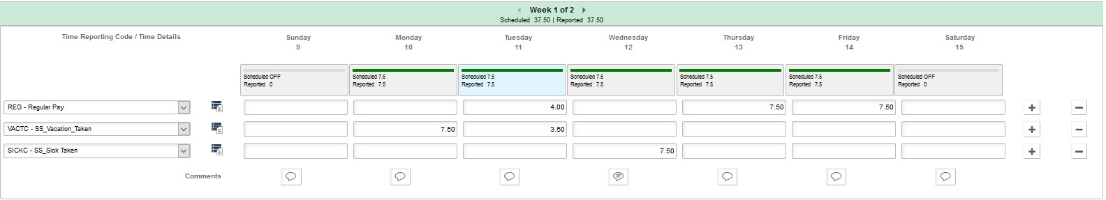
- Under each day in the pay period, a Comments icon  will be displayed. Click on the icon and a Comment box will be opened to add your comment.

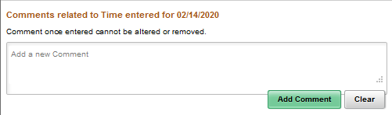

- When requesting sick leave or special leave, please enter an explanation for the leave in the Comments. When you have finished entering your comment click on the button to save your comment. Then click on the in the top right hand corner of the box to close the Comment and return to your timesheet. The Comment icon will now display lines to reflect that a comment has been added.

- If you have time to enter in the next or previous week of the pay period, you may navigate to that week and enter the time necessary before submitting your leave request(s).

- Click on the button to save your entries. The person responsible for approving your leave will receive an e-mail notification regarding your leave request. When the transaction has been reviewed, you will receive an e-mail notification confirming whether your leave request has been approved or denied.

If you exit your timesheet, prior to submitting your changes, you will receive a warning message to indicate that your changes have not been saved. This message will also appear when navigating from one pay period to another even if no changes to your scheduled or leave time were made.

Changing Leave Requests

Changes to leave entries that were previously approved will generate an e-mail notification to the Approving Supervisor. If a change to a previously approved leave request is required, please discuss the requested change with your Approving Supervisor prior to making the change to your timesheet.

Steps:

- If the leave is to be removed, review the row for the applicable leave code. If the leave being cancelled is the only leave reported for that TRC code, click on the icon at the end of the row. This will remove the entire row from the timesheet.

- In the Regular Pay row re-enter the number of hours that will be worked.
- Click on the button.

Changing a leave request when multiples dates of leave are reported:

- If multiple days of leave are reported on the same row, select the date to be changed and remove the reported leave hours for that date.

- In the Regular Pay row re-enter the number of hours that will be worked.
- Click on the button.

Changing the Time Reporting Code (TRC) for a leave request that was approved.

- If the type of leave that was originally requested, and approved, is being changed, review the row for the applicable leave code. If the leave being changed is the only time reported for that TRC code, click on the icon at the end of the row. This will remove the entire row from the timesheet.

- Click on the icon and add a new row to the timesheet.

- Select the new TRC code for the leave being requested.
- Click on the button.

Reviewing Time Summary

The Time Summary Tile will provide users with access to view their scheduled and leave time in a calendar view.

Steps:

- Click on the Time Tile.

- The Time Summary Tile will display the current pay period dates and the hours reported for the Regular Pay TRC code. If transactions have been added to the timesheet, it will also display the first TRC code reported after the Regular TRC code and the number of hours associated with that TRC code.

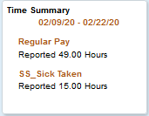

- Click on the Time Summary Tile to open the Time Summary page and to view more details related to reported or payable time.

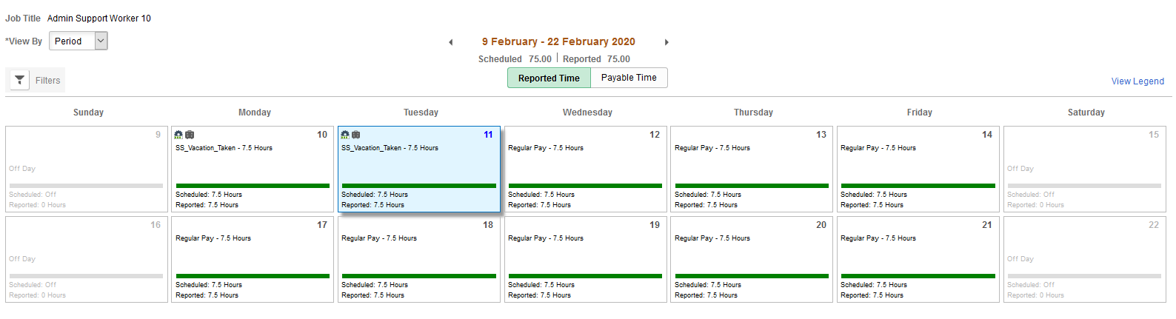

Job Title: Displays the job title associated with the timesheet being reported.

View By: This field allows the user to change the how they are viewing the page as follows:

Period: Displays the pay period dates based on the current date.

Bi-weekly: Displays the data in a bi-weekly view based on the date selected.

Monthly: Displays the data in a monthly view based on the date selected.

Weekly: Displays the data in a weekly view based on the date selected.

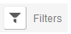 The filter allows the user to filter the data being viewed using different criteria such as Time Reporting Code, Reported Status or Combination Code.

When a filter is selected the dates reported that meet that criteria will be highlighted.

Date Range: The period that is being reported will be displayed. Use the arrow buttons to navigate to a previous or future period.


Scheduled: Reflects the number of hours associated with the assigned schedule.

Reported: Reflects the number of hours that have been reported on the timesheet including the scheduled hours.

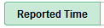 Displays the time reported on the timesheet.

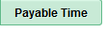 Displays payable time after Time Administration has been processed.

Click on the link to display a list of the icons that may be displayed on the timesheet and Time Summary page.

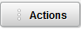 The Actions button will return you to the timesheet page. Click on Actions button and then click on the Edit Time link to return to the timesheet.

When you access the Time Summary page for the current period, the field for the current date will be highlighted. If you navigate to a previous or future period the first date displayed will be highlighted.

The date that is highlighted will also be displayed at the bottom of the page with the details associated with that date reflected.

Viewing Leave and Compensatory Time

The Leave/Comp Time Tile will provide users with access to view sick, vacation, and compensatory time bank balances. The value displayed in the Leave/Comp Time Tile is the total number of hours for all banks combined.

Steps:

- Click on the Leave/Comp Time Tile to view individual bank balances for the record selected under the Select Job field.

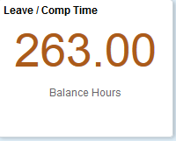

- Tiles for each leave or compensatory bank associated with the record being viewed will be displayed.

Employees will only have one sick bank and one vacation bank regardless of the number of jobs/timesheets they may have.

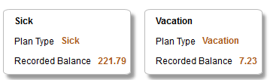

The Sick and Vacation Tiles will display the plan type and the current balance for that leave plan based on transactions that have been processed through payroll or that have been entered on the timesheet.
The compensatory bank balances displayed are based on the job being viewed. If you have multiple jobs you will need to return to previous page and select a different job to see the compensatory banks associated with that job.

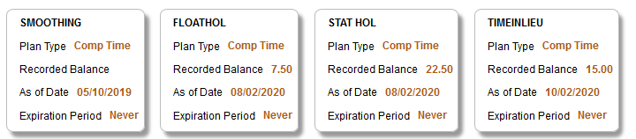

The Compensatory Time banks will display the balance for that compensatory bank based on the date reported in the As of Date field.

Leave and Compensatory Time Details:

To view the details of the transactions that have been processed to your leave or compensatory bank click on the applicable tile and the Leave Balance Details page will be opened.

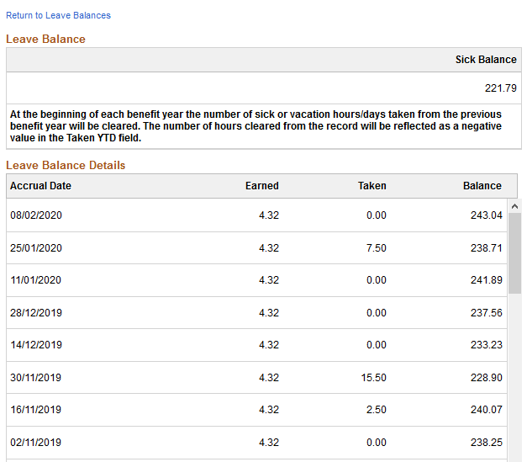

Accrual Date: Reflects the pay period end date the hours/days were processed.

Earned: Reflects the number of hours/days that were earned for the corresponding pay period.

Taken: Reflects the number of hours/days that were processed as taken for the pay period end date.

If a retro-active transaction is processed it will be reflected in the Earned or Taken field for the pay period it is processed through the Payroll Module and not the pay period it was earned or taken.

Balance: Reflects the balance in the bank based on the date in the Accrual Date field.

Click on the link displayed at the top of the page to return to the Leave /Comp Time Tiles.

At the beginning of each benefit year, the number of sick or vacation hours/days taken from the previous benefit fiscal year will be cleared. The number of hours cleared from the record will be reflected as a negative value in the Taken YTD field.

Viewing Your Pay Advice

The Pay Tile will provide you with access to view your pay advices. Pay advices for the current year and the previous nine years will be available to view.

Steps:

- Click on the Pay Tile to view your pay advices. Noted on the tile will be the most recent pay date for which you were paid.

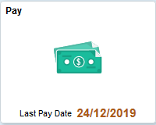

- A list of your most current pay advices will be displayed.

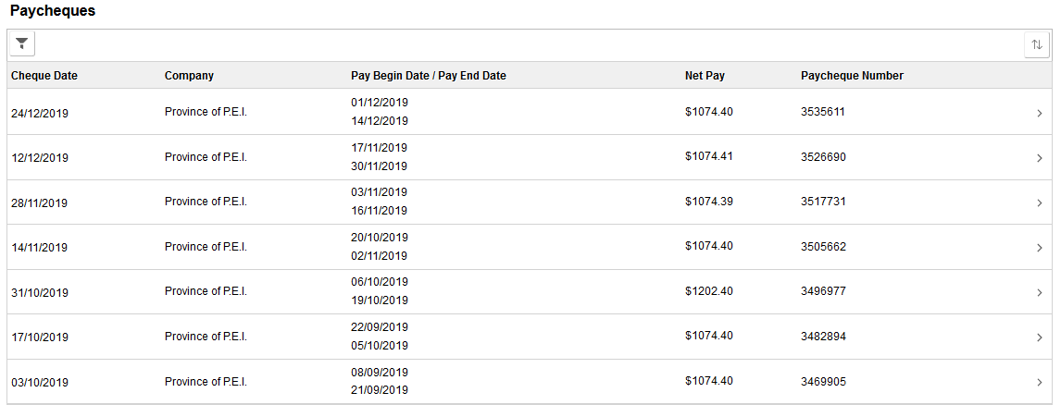
- The filter icon  allows you to search for pay advices using a date range.
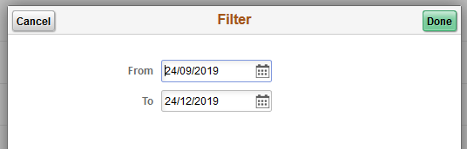

- To view a pay advice that is not listed in the view, enter the date range for the period you want to view and click on the button. A list of the pay advice(s) that fall within the date range selected will be displayed.
- You can also sort the pay advices that are displayed by clicking the 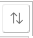 icon. A list of sort options will be displayed.

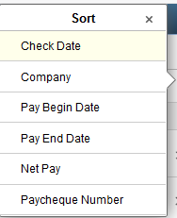

- When you select your preferred sort order, the pay advice results will be resorted based on the order selected.
- To view the pay advice details, click on the 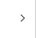 icon located after the Paycheque Number field.

- To close the pay advice, click on the icon located at the top right hand corner of the page.

Pay advices cannot be printed from this page. If you need to print a pay advice you can print your advice from the Insite portal.

Reviewing or Modifying Your Personal Details

The Personal Details Tile will provide you with access to view and/or update your personal information such as address, phone and emergency contact information.

Steps:

- Click on the Personal Details Tile.

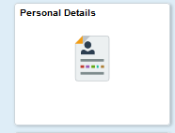

- The Personal Details page will open to display menu options to the left of the page and your current address information will also be displayed.

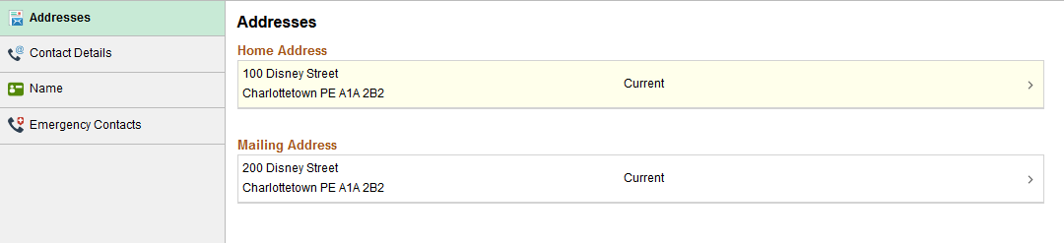

- To change your address information, click on the 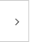 icon displayed to the right of your address. A pop-up box will be opened that will allow you to enter your new address.

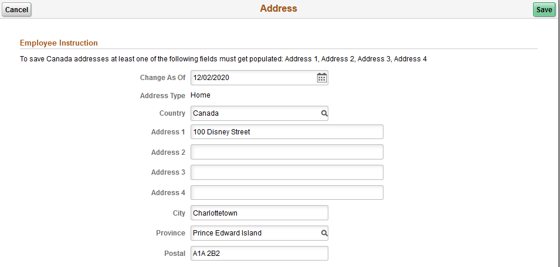

- Enter the effective date of the address change in the Change As Of field.

- Enter the new address information in the appropriate fields.

- Click on the  button to save your changes.

To make changes to your phone number(s) or emergency contact information, click on the applicable menu item and update the field information as needed.

Name changes cannot be processed through self-service. If your name has changed, please contact your Human Resource Department to have your record updated.

Viewing Your Tax Data – T4 Slip

Self-Service employees will have the ability to view their T4(s) from the Tax Data – T4 PEI Tile. Employees who have consented to receiving an electronic T4 will not receive a printed copy, but will have the ability to print their own T4 as required.

Steps:

- Click on the Tax Data – T4 PEI Tile.

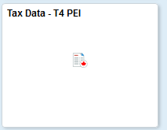

- The View T4/T4A Slips page will be opened.

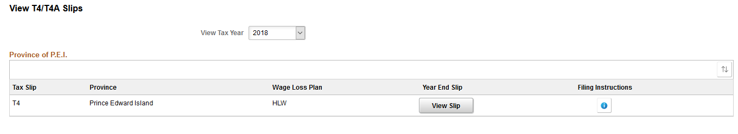

- The View Tax Year field will display the year for the latest T4 that is available. To select a previous year click on the icon and click on the year you would like to view or print.
- To view or print your T4, click on the 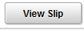 button. An Adobe pop-up box will be opened that will provide you with options for opening or saving the document. If you would like to print your T4, open the document in Adobe and select File and Print from the menu.
- To view or print the filing instructions related to a T4, click on the  icon.
An Adobe pop-up box will be opened that will provide you with options for opening or saving the document. If you would like to print the filing instructions document, open the document in Adobe and select File and Print from the menu.

Withdrawing Your T4 Consent

If you would like to receive a printed T4 slip you will need to withdraw your consent.

Steps:

- Click on the Tax Data – T4 PEI Tile.

- Click on the T4/T4A Consent button and the T4/T4A Consent Withdrawal Form will be displayed.

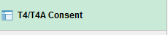

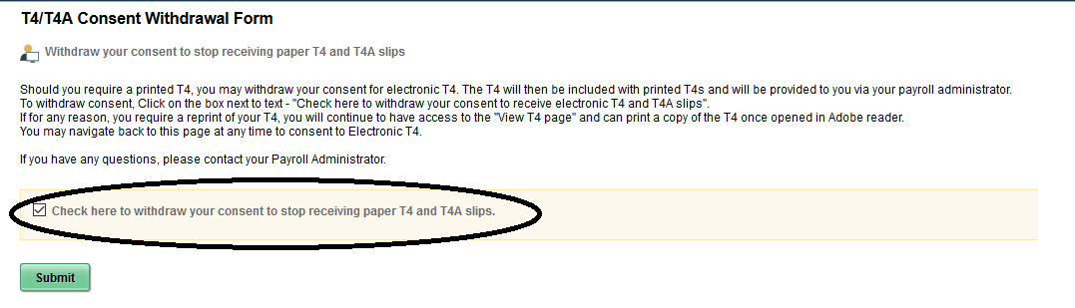

- Click in the checkbox to withdraw your consent to stop receiving a paper T4.
- Click on the 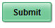 button. A pop-up box will be displayed to verify your identify.

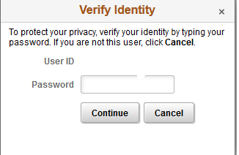

- Enter your PeopleSoft password in the Password field and click the Continue button.

- You will receive an e-mail notification confirming this change.

Changing Your Password

Your PeopleSoft password has an expiry date. You will be notified by the application when your password is 14 days from expiring. The following outlines the steps for changing your password.

Steps:

- Click on the User Administration PEI Tile.

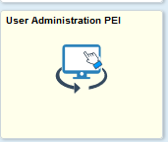

- A new page will be opened to allow you to change your password.

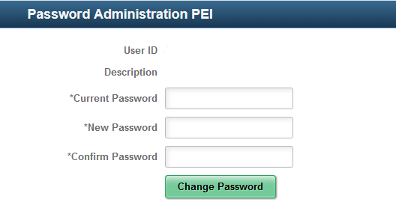
- Enter your current password in the Current Password field.

- Enter your new password in the New Password field.
The password must be a minimum of eight characters, must include at least one uppercase letter, must include one number and must include one special character.

- Enter your new password in the Confirm Password field.
- Click on the 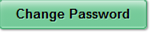button to complete the change.

Forgotten Password

Under the Password Administration PEI Tile you will also have the option for setting up the Forgotten Password feature. This feature enables users to reset their password without assistance from the PeopleSoft Help Desk or the Service Centre, however, this feature is not enabled automatically. There are certain steps that need to be followed in order to activate the Forgot Password functionality before it can be used. Once the set up criteria has been satisfied, the Forgotten Password feature can be utilized.

When you access the Password Administration PEI Tile, the left side of the page will display a navigation area. Click on the Set Up Forgotten Password button.

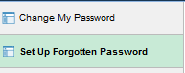

The General Profile Information page will be opened.

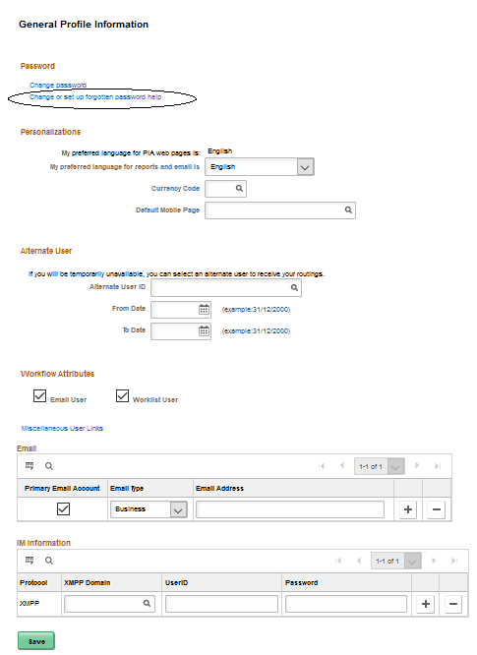
Steps:

- Click on the link. A pop-up box will be displayed that will allow you to select a security question.

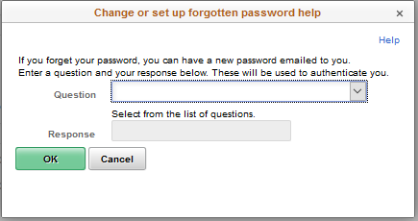

- Click on the arrow in the Question field to view the question options:

- Select one of the questions posed.
Users should select a question which will be easy to remember, but is secure.

4. Enter the answer to the question selected in the Response field.
5. Click on the button. The system will save the security question.

- Check the E-mail section of the page. If your email address is not already populated in the E-mail Address field, you will need to enter it. To enter your e-mail address:
- Check the box for Primary Email Account.
- Choose Email Type Business.
- Enter your work email address (i.e. johndoe@gov.pe.ca).
- Click the button.

The Forgotten Password feature is now ready to be used. Should you forget your password, you can click on the Forgot your password? link on the PeopleSoft sign in page.

Using the Forgotten Password feature

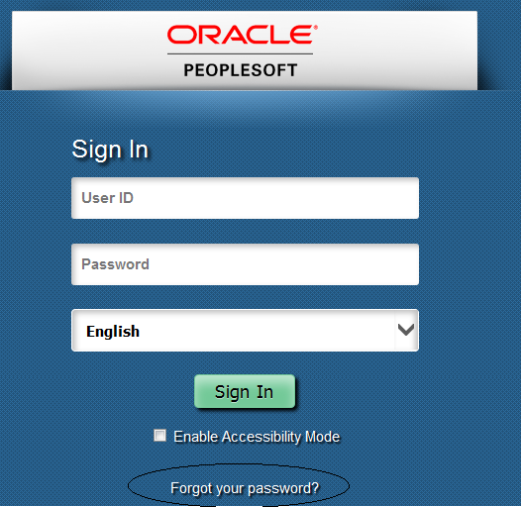

Steps:

1. Open the PeopleSoft sign in page.
2. Click on Forgot your password?

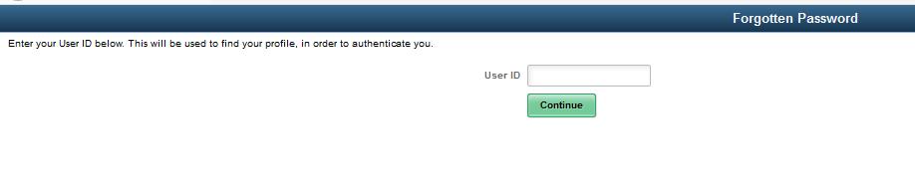
3. Enter your User ID using all uppercase letters.
4. Click on the button.
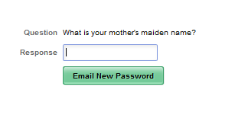

5. Answer the validation question that you previously set up.
6. Select the 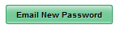button. The following message will appear:

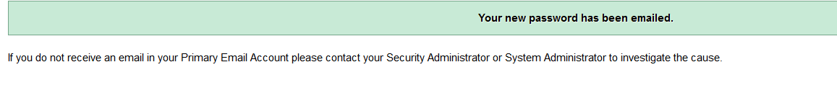

An email from PeopleSoft@gov.pe.ca with your new password will be sent to the email address you entered when setting up the Forgot your password? feature.

Click on the X button on the Forgot My Password tab.

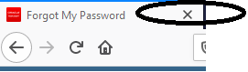

You will be signed out of the PeopleSoft application. You will need to access PeopleSoft again through your favorites menu or desktop icon.

- Navigate to the PeopleSoft sign in page and sign in using your User ID and new temporary password. Once you sign in, you should change your password to one of your own choosing. To change your Password navigate to the Password Administration PEI Tile.

Time Out Feature
The application has an automatic time-out feature. If you have not used the application within a set period of time, you will receive a pop up message warning your session will expire. If you do not do anything in the application, such as click in a field, several minutes after that, your session will expire and you will be required to sign in again.
The time-out feature also applies to the new window feature. If you have multiple windows open, but you have not been working in one of the windows, you will also receive the time-out message indicating that the window will be closed.

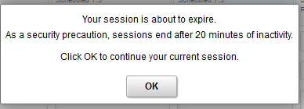

Application Navigation

The following list provides information on the links provided on the home page and all other pages of the application:

 | Resets your menu by returning you to the application’s Home page.
This icon is not used for self-service.

This icon is not being used.

The Action List icon, will provide you with the
following functions under your Home page.

- Personalizing your Home page. (Instructions for this feature are outlined below).
- My Preferences – Defaults have been set and it is not recommended that they be changed.
- Help - This is the link to PeopleBooks, which is on-line help regarding the PeopleSoft application. This link does not provide information related to our configuration or business processes.
- Sign-Out – Signs you out of the application.
Personalizing Your Home Page:

User’s have the option to change the order in which the Tiles are displayed on the Home page

When the Personalize Homepage is opened, the left side of the page will display the Roles assigned to the user’s access. The right side of the page will display the Tiles that you have access to. Click on the Tile and drag it to the preferred position on the page. Release the mouse button and the Tile will be displayed in the new location. When you completed your changes, click on the button.

Click on the 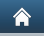 icon to return to your Home page.

